**CAPM AND FAMMA-FRENCH MODEL (with Heatmap analysis):**

CAPM and Famma-French model are two widely used model for analysing companies and stocks. These models might have some theoretical limitations, but they can be used to not only conduct a sound risk assessment but also are used for judging how well a company is performing with respect to the market.

Consequently, it was no surprise that we had to incorporate CAPM and FF model in our analysis of both companies. Let’s first discuss about some of the assumptions that we had to take for conducting the regression and constructing a model around it. One of the primary assumptions for both models is about the risk-free return. The risk-free return that we included for both companies were different. The RFr for building a model for tesla was the US-T-bill’s return (5 year) and the RFr for building a model for Net sol was the Pak-T-bill’s return (5 year). The reason for 5 year was to maintain consistency. As for all other models i.e FCF, Dividend-discount and multiplies, we are conducting an analysis for five years and then presuming perpetuity. Consequently, to map this similarity on regression we used five-years T-bill for both companies rather than any shorter period. Having said that, for US-t bill we assumed a constant rate of 2.28% (the latest) while for Pak-T-bill, we had to do some workings. First, we calculated the returns on Pak-Tbill by moving averages of Pak-T-Bill’s price and then we calculated an average of all these calculated average i.e grand mean of the returns and we assumed this as our Rfr for CAPM and FF of Net Sol.

Afterwards we took stock data from investing.com for year 2010-2019(April 11). The data was on daily bias. The reasoning being that we wanted to improve the accuracy of both of our models and if we were to give more data to our model, we were to get improved values of our beta. Moreover, after conducting some secondary search on the internet, we concluded that it was imperative for us to use daily data so that our model does not throttle due to lack of data.

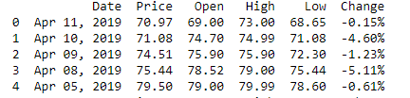

Table 1 NetSol Data(First five rows)

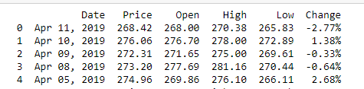

Table 2 Tesla Data(First five rows)

Now, what we did was to use the change columns as the the dependent variable for both of our model. The change was basically the return on individual stocks of the company. As both of the company were technological-oriented companies it was no surprise that their return had high variability, as shown by the plots:

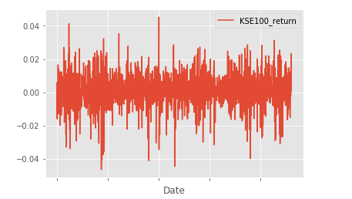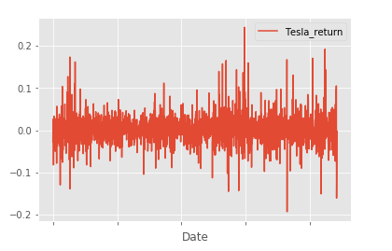

Afterwards, for each row of dataframe for both companies, we subtracted return from RFr. As explained earlier RFr used was different for both of the companies ,to make or model more realistic. Now, let discuss the CAPM and FF model in more detail.

The equation for CAPM is:



Mapping this equation to our model ,its clear what E(Ri)-Rf is.However E(Rm) needs further explanation. Rm is the return for the whole market and this return should capture the whole working of the market. Conseuqently, we used KSE-100 return in the model of Netsol and S and P 500 return for Tesla. The reason is self-explanationary as why we used differet market benchmarks for the companies. Again we took the data of S and P 500 and KSE 100 from investing.com. To maintain consistency, we took at the data for the same time period at same frequency i.e dialy. Finally, we took E(Rm)-Rfr(S and P 500 return was subtracted from US-T-bill and KSE-100 from Pak-T bill) as independent variable of CAPM regression model. We ran the regression and the result was as following for both of the companies(Graphs on next page):

The beta for tesla is quite high which means its quite responsive to the changes in the market, further this mean that tesla stock posses a large chuck of systematic risk. However, being more responsive mean that tesla stock might have large margin for an investor. Due to high beta, the expected returns might be very high in the near future. This is also what we expect from the market sentiments for the Tesla. Conversely,Netsol also has a very high beta which means its quite reactive to the market. This seems realistic for a techonlogical oriented company operating in the Pakistan, as the technological sector is expanding at an expotential rate which means the expected return with high beta is a real possibility. Further, higer beta means that Netsol will have a higher correlation with the Pakistan economy and will perform better in time of booming economy. Moreover, as both of our companies has beta above 1, this mean that both companies are riskier in terms of investment however at the same they could provide high returns.

Afterwards, we conducted the FF model with SMB and HML data taken from internet

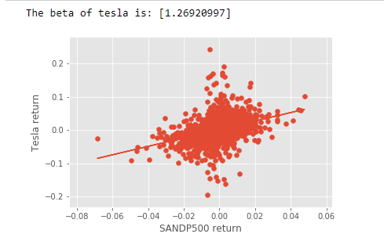

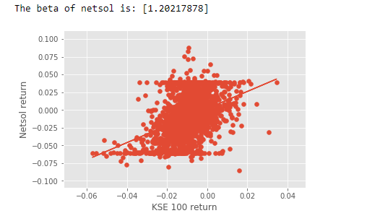

which was resampled to dialy basis to accommodate our assumption. However,as expected this model did not perform that well on our companies, the first reason could be lost of data due to resampling and second being that our selected companies are showing an outlier behaviour in recent times. This does not mean that model was a complete waste but what this imples is that usefullness of FF model under our context was weak as compared to CAPM. The results of FF were as follow:





The interpretation was not need as both Bs and Bv showed what we term as outlier behaviour but our model accuarcy is still justified as it complment CAPM beta(B).

Finally, we calculated mean and standard deviation for both of our models and tried to visulised their distibutions:

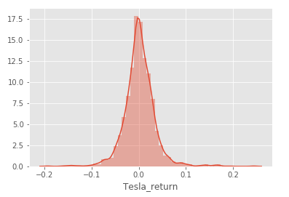 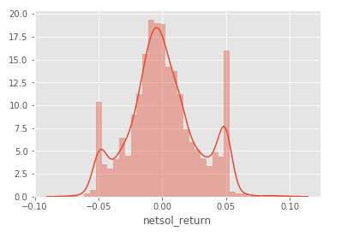

Clearly, tesla not only has high return but also has lower standard deviation which mean it’s a better stock to invest given both of the distrubutions. Further we calculated the correlation

for each of the stock and visualise it:  
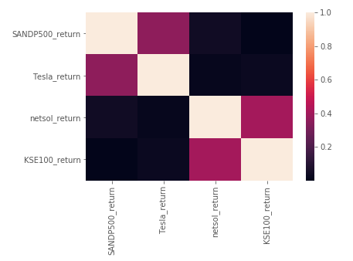

The heatmap is self-explanationary but the main insight is that Netsol and Tesla are not having a positive relation in terms of their returns. Further, the heatmaps all tend to justify our calculated beta as correlation between netsola and kse 100 is high and same goes for the tesla and sp500.